"RUNNING TO SAVE A LIFE" May 21, 2016

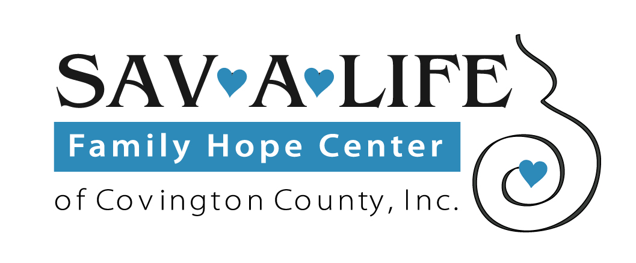

RACE REGISTRATION FORM

Full Name:
Gender: Male/Female (circle one) Age: (on race day)
Activity: 5K Walk / 5K Run / 10K Run (circle one)
Mailing Address: City: State/Province: Zip/Postal Code: Phone: Email: Shirt size: (circle one) AM AL AXL A2XL Youth sizes: S M L XL
EVENT INFORMATION:
"Running to Save a Life" will begin at 8 a.m. at the FOP Lodge, Bush Isle Road, Gantt, Alabama.
Sav-A-Life of Covington County is non-profit, interdenominational Christian ministry sharing Jesus to save lives. We help women experiencing a crisis pregnancy by offering confidential, compassionate care, as well as maternity and baby clothing, diapers, etc. Our clients can participate in "Earn While You Learn" parenting classes. All services are offered free of charge. For more info, find us on Facebook - Sav-A-Life of Covington County.

Race Fee: Registration fee for 5K Run/ 10 K is $25. Registration fee for participants registering on race day
will be $30.

Note: Race T-shirts guaranteed for pre-registration only. To be pre-registered, your completed
registration form must be received on or before May 10.
Those registering on race day, May 21, are not guaranteed a shirt or correct size.

Payment: Make your check payable to Sav-A-Life of Covington County, and mail completed registration form and check to Sav-A-Life of Covington County, P.O. Box 487, Andalusia, Alabama 36420.

EVENT DISCLAIMER: Please review the following waiver and disclaimer. By adding your signature, you accept this waiver and disclaimer. Waiver and Release: By participating in this Event, I do so at my own risk. I assume all risk of injury, illness, damage or loss to me or my property that might result, including without limitation, any loss or theft of personal property. I consent to medical treatment in the event of an injury, accident and/or illness during the Event. I agree on behalf of myself (and my personal representatives, heirs, executors, administrators, representatives and employees from and all claims or causes of action (known or unknown) arising out of their negligence. I acknowledge that I have carefully read this ‘Waiver and Release’ and fully understand that it is a release of liability. By my signature below, I am waiving any right that I may have to bring legal action to assert a claim against any and all Event sponsors for their negligence. I hereby grant full permission to any and all of the foregoing to use my name and likeness in any broadcast, telecast, video or print media reporting or advertising of the Event without compensation.

Signature Date:

Parent or Guardian if under 18

No refunds will be issued for any reason

